Atmosphere Study Guide

In the diagram above, the air pressure would be lowest near the
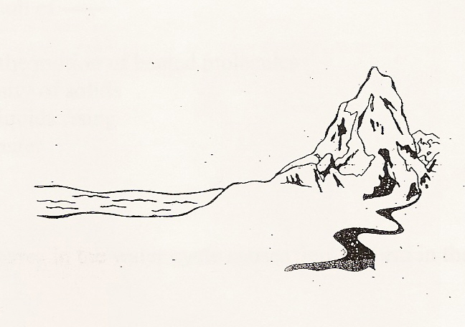

.

From earth to space, the main layers in our atmosphere are:
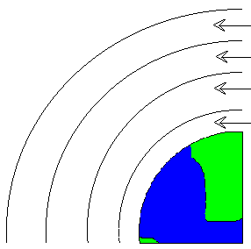
.

Convection is the result of -----

The main way heat is transferred in the atmosphere is by

The layer in our atmosphere in which weather occurs is the

As elevation increases in the atmosphere, air pressure does what?

Convection currents in the air take place because
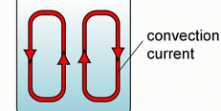

Instruments used to measure air pressure are called

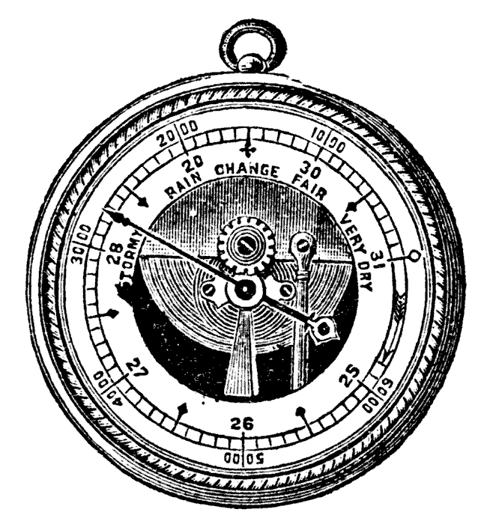

.

At which point is there the LEAST amount of air pressure?
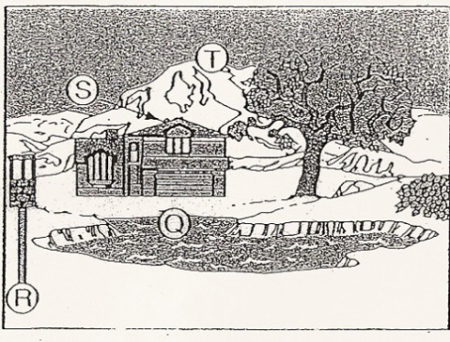

Heat transfer between two substances that are in direct contact is called

.
When climbing a high mountain, you get out of breath easily because
A the percentage of oxygen in the air decreases.
B the air is more dense.
C there is less oxygen in each cubic meter of air.
D air pressure is greater

Use the Temperature in the Atmosphere graph to answer the questions:

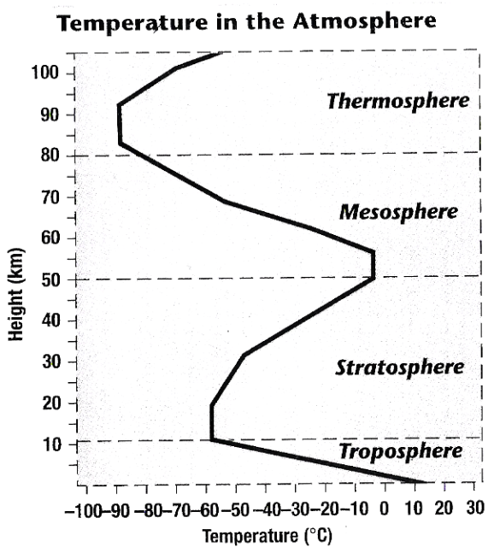

15. Which layer of the atmosphere has the lowest temperature?

16. The range of temperatures found in the stratosphere is about _____C degrees.

17. Which of the following best describes how temperature changes as altitude increases in the troposphere?

18. The less mass in a given volume of air, the

19. As you rise upwards in the atmosphere, air pressure

20. Cool air tends to
A. be less dense and flow over warm air.
B. be lifted up by more dense warm air.
C. be more dense and flow under warm air.
D. mix easily with warm air masses.

21. Local winds differ from global winds because they
A. are caused by unequal heating within a small area.
B. are caused by differences in cloud cover.
C. are due to unequal rainfall.
D. are not influenced by air masses

23. Increased carbon dioxide may cause global warming by

24. Which gas is present in the largest quantity in our atmosphere?

25. Air has pressure because
A the stratosphere is thick.
B air has mass.
C wind moves the air.
D temperature warms the air

26. As you climb up a tall mountain, the air pressure, density of the air and amount of oxygen….

27. In what way does the glass of a greenhouse model carbon dioxide and other gases in Earth’s atmosphere?

29. What gas is there less of in the atmosphere over a desert than in the atmosphere over a rain forest?
A oxygen
B nitrogen
C water vapor
D carbon dioxide
30. The ozone occurs in which layer of the atmosphere?
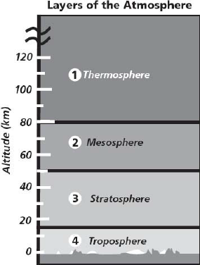

32. What is happening at point C in the diagram?
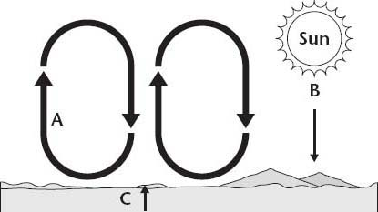

A The sun warms Earth's surface through radiation.
B The ground warms the atmosphere through conduction.
C The air warms the ground through convection.
D Heat moves through the air due to convection.
31.
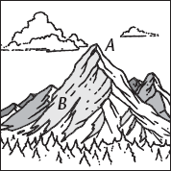
33. As the altitude increases, air pressure…

