**Atmosphere Study Guide**

In the diagram above, the air pressure would be lowest near the

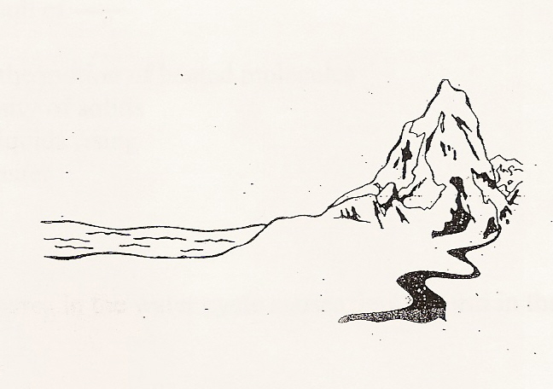

.

From earth to space, the main layers in our atmosphere are:

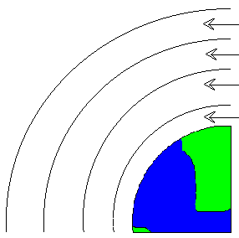

.

Convection is the result of -----

The main way heat is transferred in the atmosphere is by

The layer in our atmosphere in which weather occurs is the

As elevation increases in the atmosphere, air pressure does what?

Convection currents in the air take place because

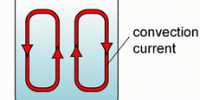

Winds are caused by differences in

* 1. precipitation.
  2. humidity
  3. air pressure
  4. turbulence

Instruments used to measure air pressure are called

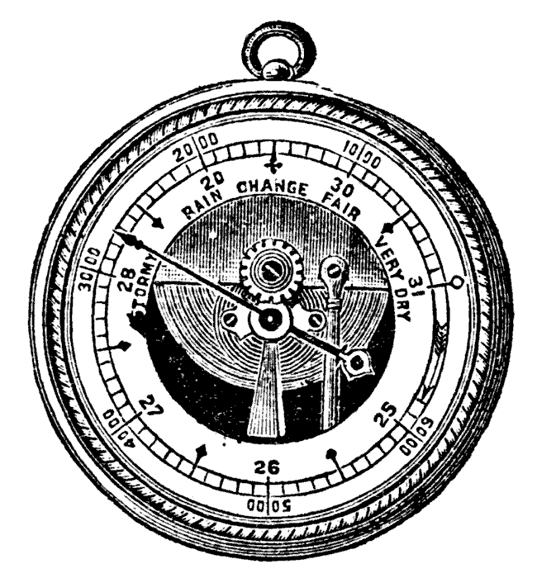

.

At which point is there the LEAST amount of air pressure?

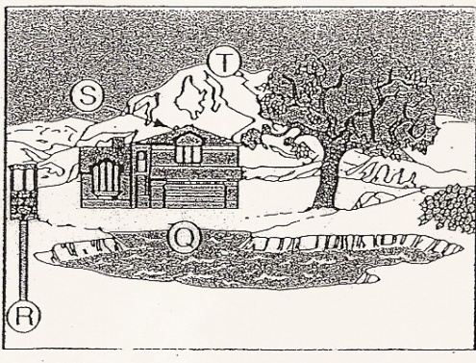

Wind speed is measured by a (an)

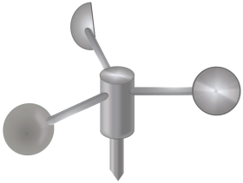

. Heat transfer between two substances that are in direct contact is called

.

. Unlike local winds, global winds generally

A are not influenced by heating of Earth’s surface.

B are unpredictable.

C change directions from day to day.

D blow from specific directions over long distances.

When climbing a high mountain, you get out of breath easily because

A the percentage of oxygen in the air decreases.

B the air is more dense.

C there is less oxygen in each cubic meter of air.

D air pressure is greater

: Use the Temperature in the Atmosphere graph to answer the questions:

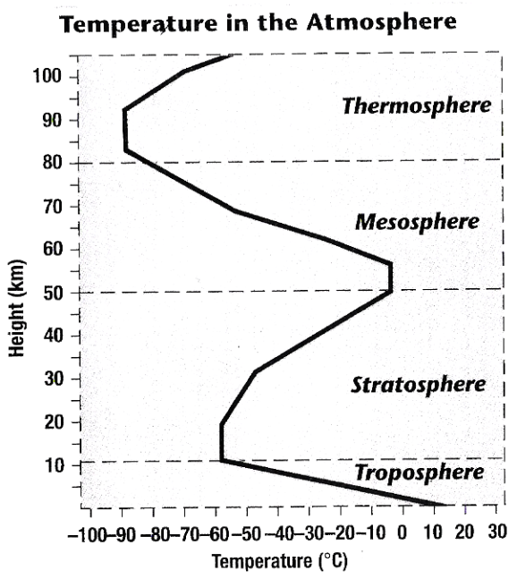

15. Which layer of the atmosphere has the lowest temperature?

16. The range of temperatures found in the stratosphere is about _____C degrees.

17. Which of the following best describes how temperature changes as altitude increases in the troposphere?

18. The less mass in a given volume of air, the

19. As you rise upwards in the atmosphere, air pressure

20. Cool air tends to

A. be less dense and flow over warm air.

B. be lifted up by more dense warm air.

C. be more dense and flow under warm air.

D. mix easily with warm air masses.

21. Local winds differ from global winds because they

A. are caused by unequal heating within a small area.

B. are caused by differences in cloud cover.

C. are due to unequal rainfall.

D. are not influenced by air masses

22. During the day the land warms up faster than water. The air above the land gets warmer than the air over the water. This warm air is less dense. It expands and rises. Cool air blows inland from over the water causing what type of breeze?

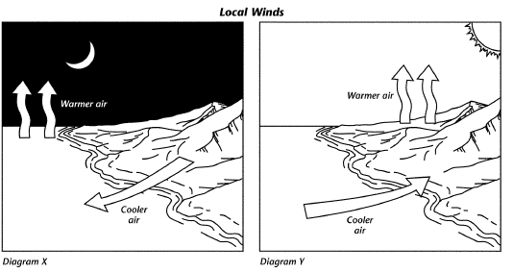

* 1. fast breeze
  2. land breeze
  3. cool breeze

D. sea breeze

23. Increased carbon dioxide may cause global warming by

24. Which gas is present in the largest quantity in our atmosphere?

25. Air has pressure because

A the stratosphere is thick.

B air has mass.

C wind moves the air.

D temperature warms the air

26. As you climb up a tall mountain, the

27. In what way does the glass of a greenhouse model carbon dioxide and other gases in Earth’s atmosphere?

28. The wind blowing over your skin removes body heat. The increased cooling this wind can cause is called the

A doldrums.

B lake-effect snow.

C windchill factor.

D convection currents.

29. What gas is there less of in the atmosphere over a desert than in the atmosphere over a rain forest?

A oxygen

B nitrogen

C water vapor

D carbon dioxide

30. The ozone occurs in which layer of the atmosphere?

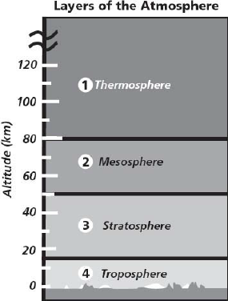

31. As Earth rotates, the paths of winds and currents curve, as shown in the diagram above. What is this called?

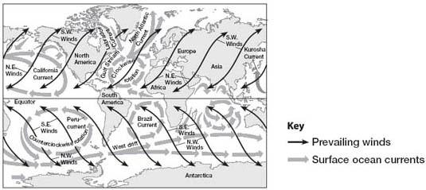

A doldrums

B El Niño

C La Niña effect

D the Coriolis effect

32. What is happening at point C in the diagram?

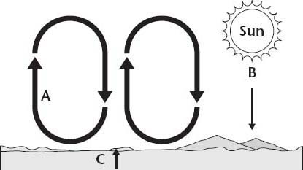

A The sun warms Earth's surface through radiation.

B The ground warms the atmosphere through conduction.

C The air warms the ground through convection.

D Heat moves through the air due to convection.

31.

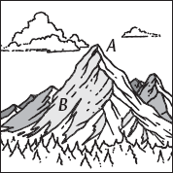

33. As the altitude increases, air pressure…

SHORT ANSWER: 2 point

Answer the following short answer question on a separate sheet of paper.

Describe the difference between high air pressure and low air pressure.